A
DISSERTATION PROJECT WORK REPORT
on
A Novel Brain Tumor Detection Methodology Design Based on Deep Learning Assisted Intelligent Neural Classification Strategy
Submitted to
JAWAHARLAL NEHRU TECHNOLOGICAL UNIVERSITY, HYDERABAD
In partial fulfilment of the requirement for the award of the degree of

MASTER OF TECHNOLOGY
in
COMPUTER SCIENCE AND ENGINEERING
Submitted by

 | T Mohan Venkatamadhu |  | : | 237Y1D5804
Under the Guidance
of
Dr. B. Ravi Prasad
Professor
 |  | 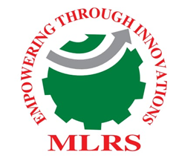
DEPARTMENT OF COMPUTER SCIENCE AND ENGINEERING
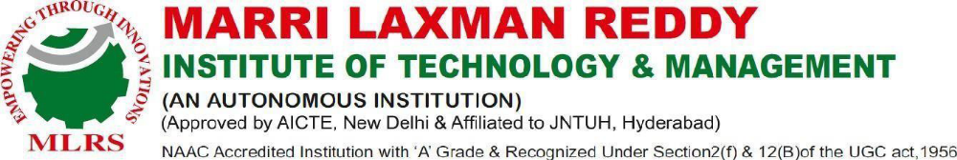
APRIL 2026

